Q5. Read the following description concerning program design and then answer sub-questions 1 through 4.

A subprogram that calculates the day of the week for a given date has been created and is being tested.

[Description of Subprogram]
This subprogram calculates the day of the week for a date (given according to the western calendar). If there is an error in the date that is entered, the program returns a corresponding error code.
(1) The date is given in the format “yyyy, mm, dd” (yyyy: four digits for the year (in the western calendar); mm: two digits for the month; dd: two digits for the day of the month).
(2) If the date information is valid, the program returns the corresponding day of the week (SUN, MON, TUE, WED, THU, FRI, SAT).
(3) If the date information is invalid, the program returns, as a return code, an error code that corresponds to one of the three types of errors described in Table 1.

Table 1 Date Checks and Error Codes
Error code | Description of check
E1 | The input values are checked to make sure that they are within the allowable ranges: 1900 to 2299 for the year, 01 to 12 for the month, and 01 to 31 for the day.
E2 | If the day is 31, the month is checked to make sure that it is not February, April, June, September, or November. If the day is 30, the month is checked to make sure that it is not February.
E3 | If the date given is February 29, the year is checked to make sure that it is a leap year.

[Testing the Subprogram]
Based on the description of the subprogram, the test items were set and test data was created with due consideration given to the boundary values. Table 2 shows the test data and the expected correct results.

Table 2 Test Data and Expected Correct Results
Test items | Test data and results [in the format “(test data; result)”]
Year value | (1899,12,31; E1), (1900,01,01; MON), (2299,12,31; SUN), (2300,01,01; E1)
Month value | (2001,00,01; E1), , (2001,12,01; WED) , (2001,13,01; E1)
Date value | (2001,01,0 ; E1) ,, (2001,01,01; MON), (2001,01,31; THU), (2001,01,32 ; E1)
Combinations of months and days in non-leap years | (2001,02,28; WED), (2001,02,30; E2), (2001,02,31; E2), (2001,03,31; SAT),  (2001,04,30; MON), (2001,04,31; E2), (2001,05,31; THU), (2001,06,30; SAT),  (2001,06,31; E2), (2001,07,31; TUE), (2001,08,31; FRI), (2001,09,30; SUN),  (2001,09,31; E2), (2001,10,31; WED), (2001,11,30; FRI), (2001,11,31; E2),  (2001,12,31; MON)
February 29 | (1996,02,29; THU), (2000,02,29; TUE), (2001,02,29; E3), (2100,02,29; E3)
Note: 1996 and 2000 are leap years, 2001 and 2100 are not leap years.

Sub-question 1
From the answer group below, select the term which describes the type of test that is being conducted with the test data shown in Table 2.

Answer group:
a) Integration test b) Performance test
c) Endurance test d) Black-box test
e) White-box test

Sub-question 2
From the answer group below, select the correct answer to be inserted in the box in Table 2.

Answer group:
a) (2001,01,01; MON) b) (2001,01,33; E1) c) (2001,06,01; FRI)
d) (2001,00,99; E1) e) (2002,02,29; E3) f) (2010,13,14; E1)
Sub-question 3
When the subprogram was executed using the test data shown in Table 2, the response for the year 2100 test data in the “February 29” test item was “2100, 02, 29; MON” instead of the expected correct result indicated by the underlined data in the table. From the answer group below, select the correct conclusion that we can draw from these results.

Answer group:
a) Because February 29 only comes once every four years, the impact from this problem is small. Considering the effort that would be required to correct this error in the program and the possibility that the correction could give rise to new problems, it is not appropriate to attempt to correct this error.
b) Because the correct response is generated for non-leap years, it is best to change the underlined test data to a non-leap year so that all of the test results will be correct without reducing the amount of test data.
c) It is likely that there is an error in the leap year calculation processing. Therefore, to correct the subprogram, the first step is to check the portion of the code that handles leap-year processing.
d) Although the number of days varies from month to month, the range of values for the month is always “1” to “12,” so there was no need to conduct a range test on the month value.
e) Because the year 2100 is 100 years ahead in the future, there is no need to correct the sub-program.
Sub-question 4
The figure below is a flowchart for calculating the date of the second Monday in October in a given year (assume the year is 2000 or later) using the debugged subprogram.
From the answer group below, select the correct answers to insert in the boxes .

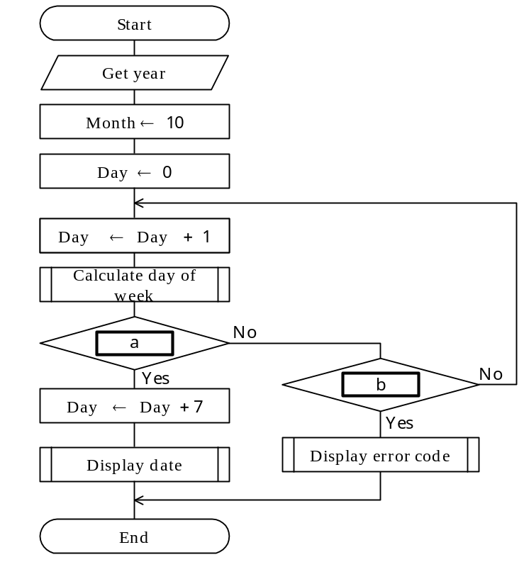
Fig. Flowchart for Obtaining the Date of the Second Monday in October

Answer group:
a) Day > 31?
b) Day ≦ 31?
c) Is the return value an error code?
d) Is the return value “MON”?
e) Is the return value “SUN”, “TUE”, “WED”, “THU”, “FRI” or “SAT”?
f) Is the return value “SUN”, “MON”, “TUE”, “WED”, “THU”, “FRI” or “SAT”?

